**Phase 33**

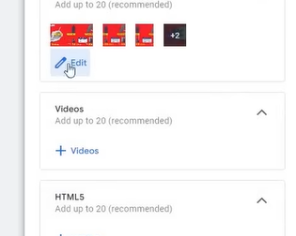

Click on video

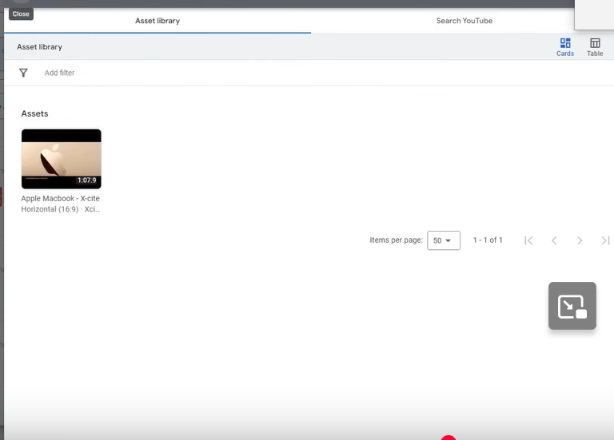

Now you have to upload your video in youtube etc

And go to Search Youtube tab

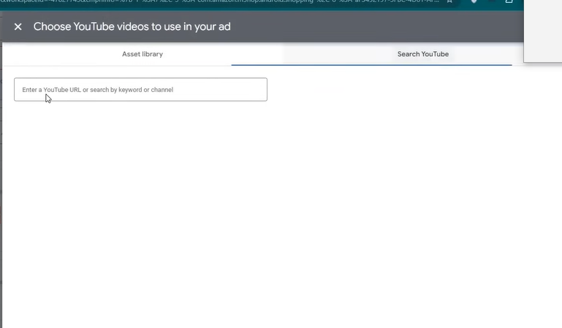

Now paste the url of the video and then select it by checking it and then click on save button

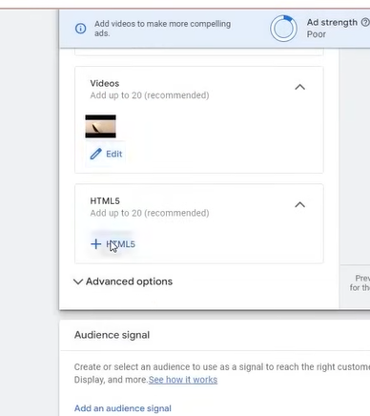

You can click on HTML5 to make a banner designed by HTML

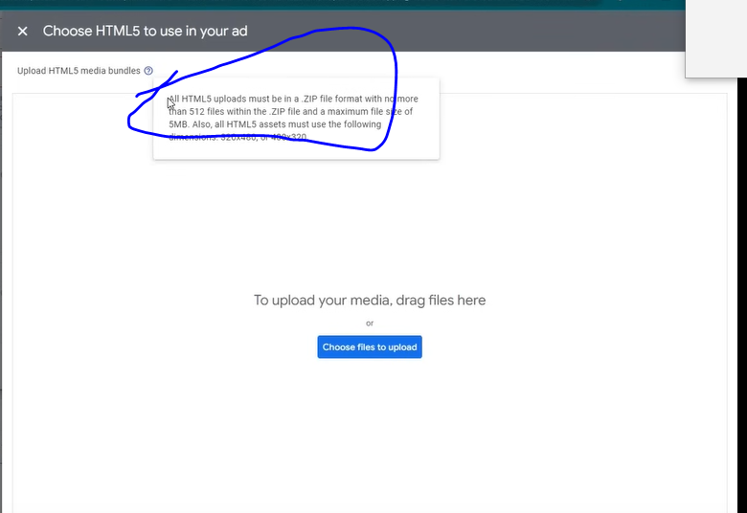

It is a slightly advanced technique

Only designer can help you making it

You have to give above marked information to them or these guidelines that we want that type of assets

5:40:30

Then he will made you this

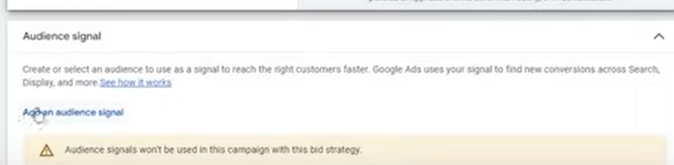

We will conver this Audience signal later in performance section(who knows)

It will be applied now later it will be taught to us

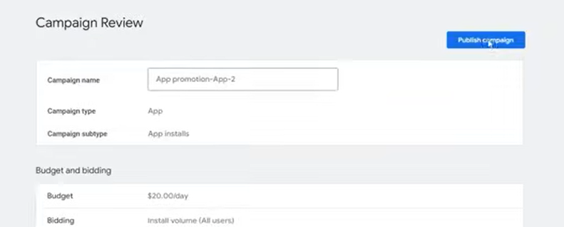

Click on puiblish campaing to publish campaign

NOw our app promotion event is complerted

Teacher have added videos for the promotion of the app

Before assinf videos if you do this step then it will be better

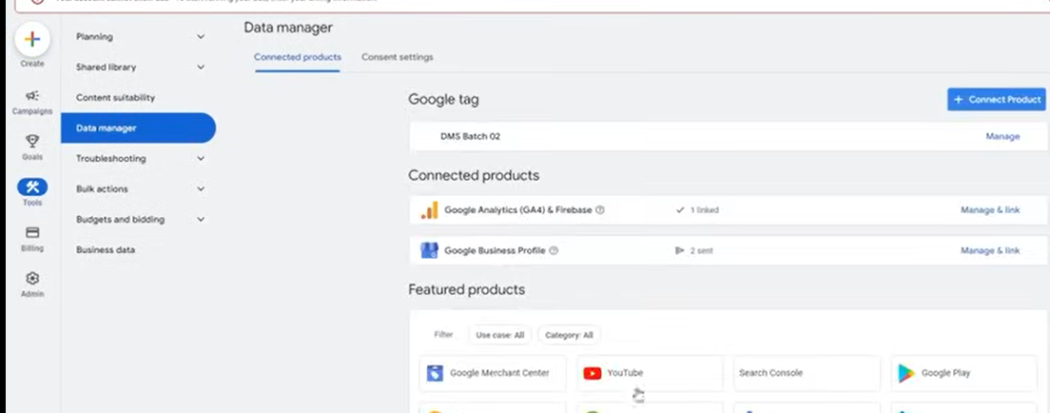

Go to Tools and then to Data manager as shown above

You choose youtube in the featured products

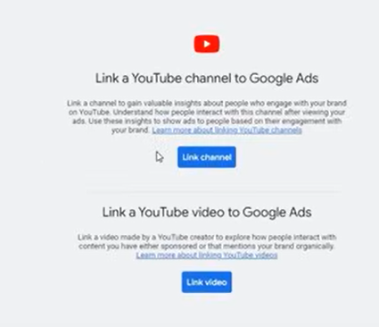

Whateveer video you are addinf make it link with google ads the benefit of this is that you will have additional audience , how many subscriber ot views we have got on our video

How much percentage of videos people has watched and who has not matched with it so you get additional insights there So it is important for that

Again it is important for Video campaign

You have to link it one not again and again

**Lesson 15:-**

In this lesson we will learn about **Video Campaigns**

You can also call it youtube campaign because its mainly ad is shown I youtube only

First we need to understand the type of video campign and how they work

It will not happen that you make ad of a video and it works no

Its first type is

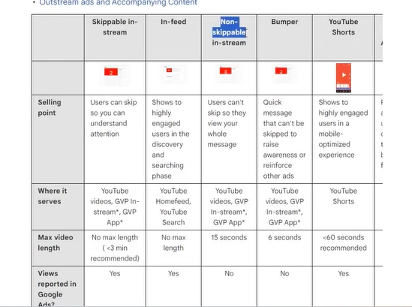

**Skippable in-stream**

It is the skippable ad that come in between of a video

It has no maximum length but the recommended one is three minutes

Next is **infeed**

Means inside youtube

I youtube when you scoll then you see ad or sponsored ads then it is called infeed ads it has noi maximum length

Now next is **Non Skippable in-stream**

Its maximum length is 15 seconds

These ads come in between the video and it is non skippable

Next is **Bumber ad**

Its length is 6 seconds

It is quick ad which you have often seen in it in TV commercial that there is a long format ad we make it a short term ads in between the video

IT can be termed as bumper ad but in youtube the bumper ad that has length of 6 second

In which you want to quieckly send your message to the people and increase awareness to the

People . Its example is below

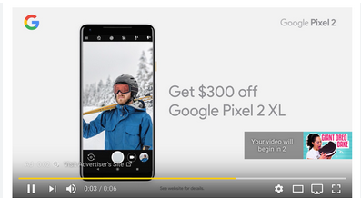

Now comes **youtube shorts**

It has been a while when it was introduced

IN this when you see youtube shorts and then you see some sponsored ads in between shorts

Its maximum length is 60 seconds

Next is **Outstream and accompanying content**

It measn this ad is not visible in youtube

It measn that it is visibek outside yoututbe in different websites , indifferent apps

There you must have seen it in some websites nad there you can see some video ads then it is called outstream ads

If you have downloaded an app and ad is coming in it and video ads are coming in it then it is outstream ads

It also does not have any maximum length

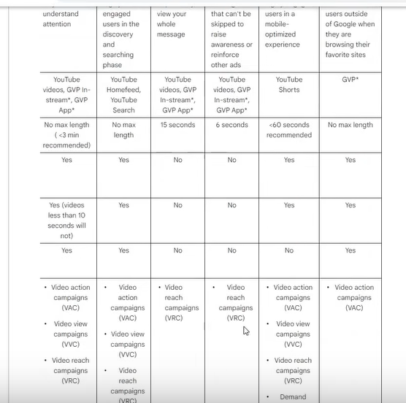

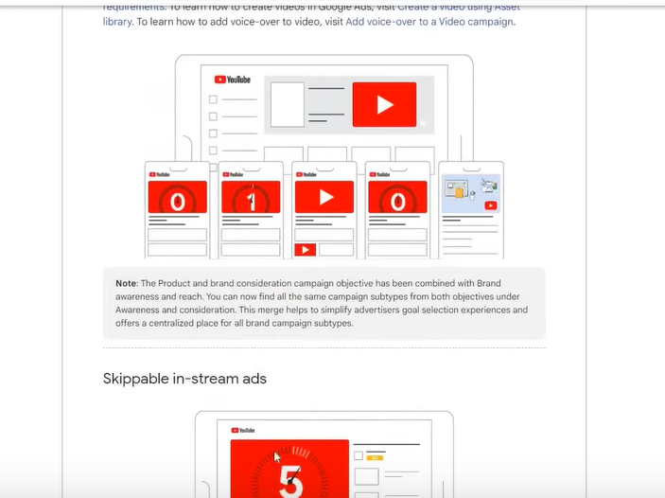

Now the teacher has told us some basics

Now we creat some video ads

So create a new campaign

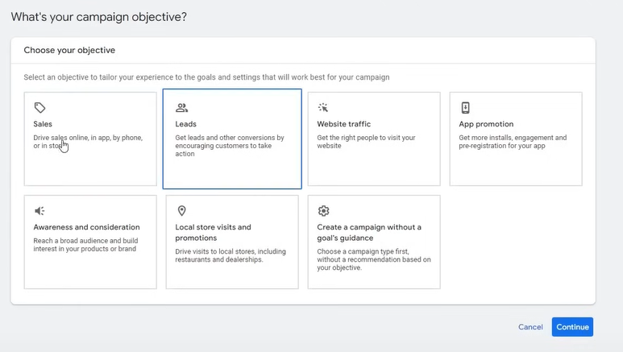

Normally you have to do it normally by the iobjective you have

If you have sales then choose sales and then cointinue and then choose video campaign

If you choose leads then the same process

By this way the best possible campaings options will be added

And you can make ad thro=orugh which you can get leads

Ad in case of sales some types of video will be added to increase sales

You can also do for Website traffic , App promotion, Awareness and Campaigns

If you make ads in a format in Awareness and campaigns then it should increase awareness

Since teacher want to explain all the format so he choosed Create a campaign without a goal’s guidance

So that we have all the format

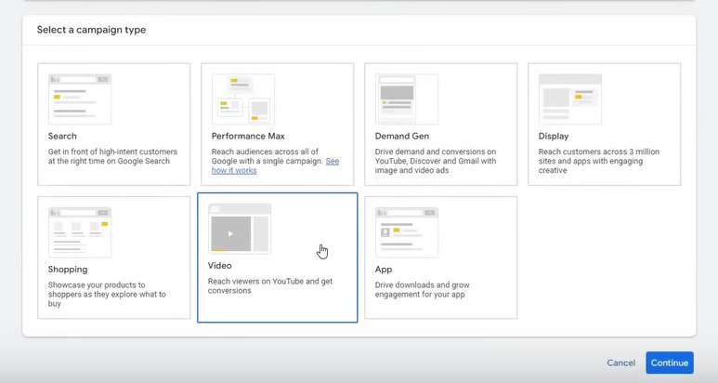

IN campaign type we chose Video

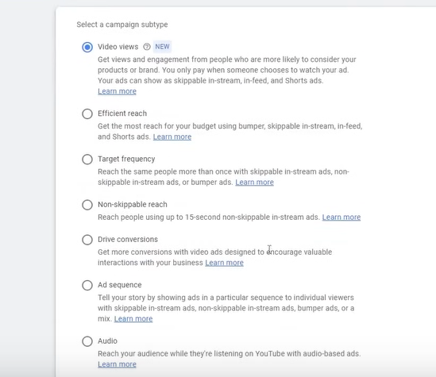

Now you see above format

The video views is newly introduces format

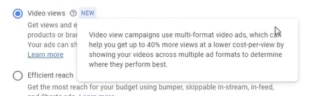

What format it is made of it gives result also

If this is video view then it will give you video views

If it is efficient reach then it will give you more reach

Similarly if it is hten it will giv you more CL and lead

It is not like that you make coose video views and you are ising t for sale then it is not possible

We choose video views for now and click on continue

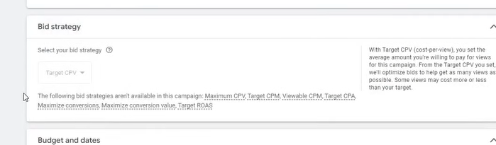

We does not see a bid strategy there that is target CPV

IT is locked and you don’t have to do anything special here

It will run by default

CPV means cost per view

It tells the charge thatshould cut on your view

You set campaign name

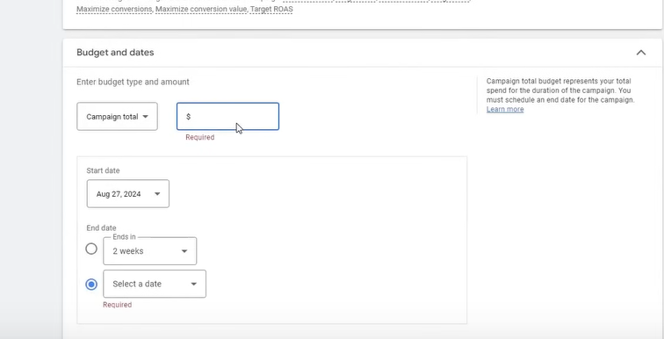

You tell the campaign total budget

You can tell the end date when it will be stopped

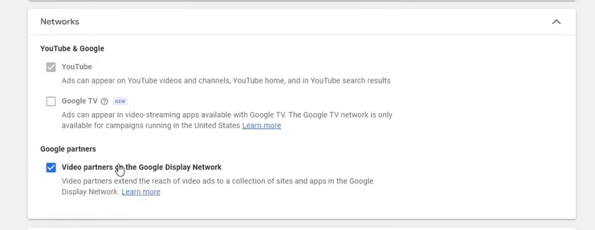

Here it will have networks

The google Partner s are those which we have talked in outstream

You can check it to run the video on other apps It is all upto yuou to check it

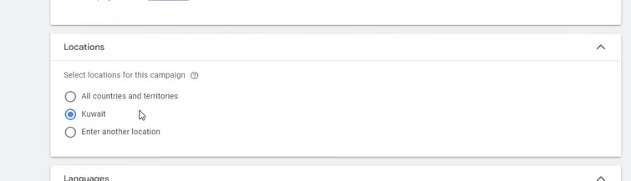

You now target a country

Then you choose languages

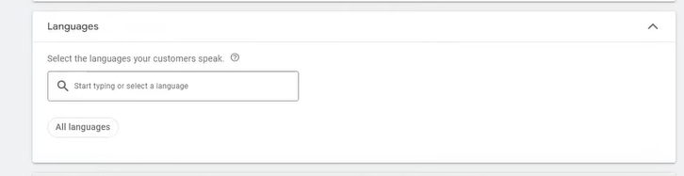

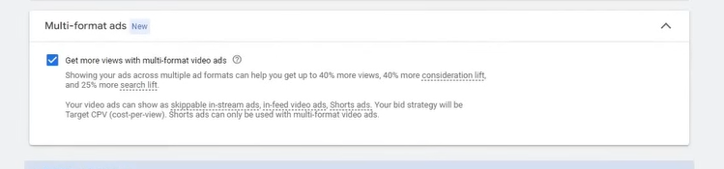

If you want more views then you need to check it

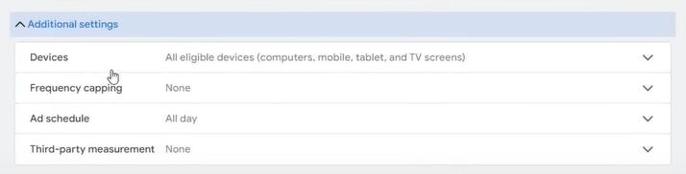

Now there are further options

IN display we tell that what devices are eligiv=ble to show these ads

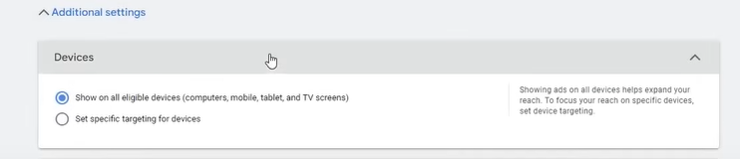

You can check the first radio button to show ad on all eligible devices

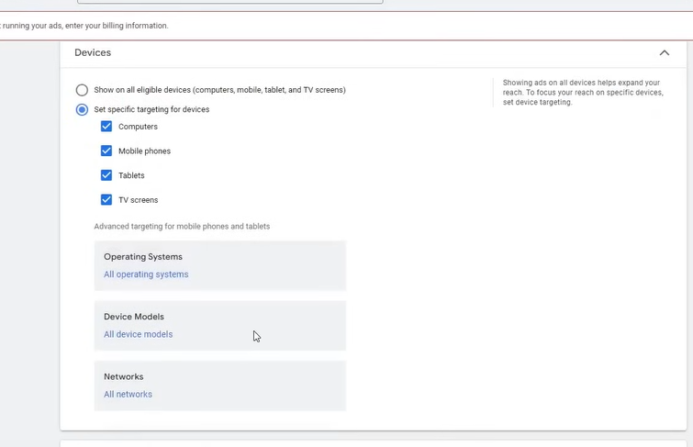

Check the second radio button ro run ads on specific devices as shown above

You can even customize it according to operating system

**Phase 34**

You can also do for device modal

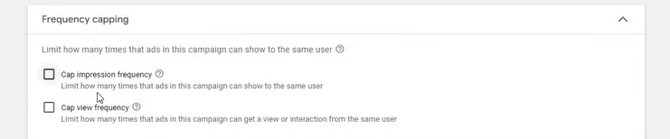

Now comes the frequency capping

It has two option that is

**Cap impression frequency**

**Cap view frequency**

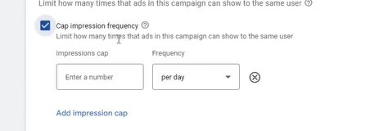

In cap impression frequency you want to tell the ad should be shown to the persom how many times

You must have seen it normally that you are visiting a website and its ad are hown everywhere

You see an ad and you see it repeatedly why it is it happens because of frequency

It may be possible that they have set the frequect such that you see it repeatekdy

If they have not added any cap then it depends on Google How many times it shows to us

The ideal frequency ATT is 7 in frequency field you can set per day , per week, per month

Nor mallyh Teacher does not cap impression but views

Or even does not do it because google can handle it properly

Now comes Cap view frequency

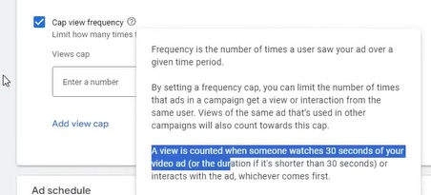

If some oine view your ad for 30 seconds or for a particular duration (in general case)

If the person has viewed the ad for 30 seconds hten the ad will be shown to them otherwise will not show to them

On the other hand in impression even if the user just have scrolled the it will be counted as impression

You can set the frequency as 7 per weeks or 10 per weeks

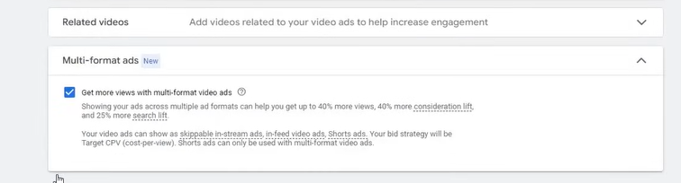

Now comes the related videos

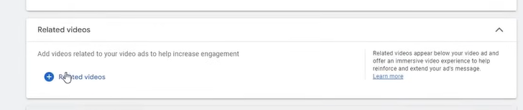

It means the video you will put beow the sponsors banner there will be videos related to it

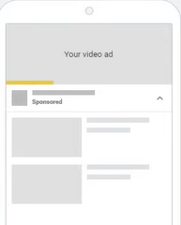

Whatever related video you will ad will be shownb there

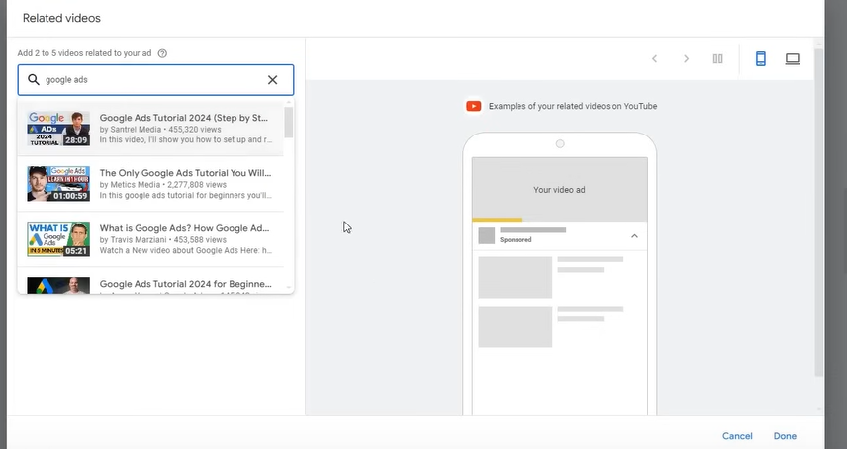

For example we search topic which our ad is based on

And then choose the video you want to come below your video ad

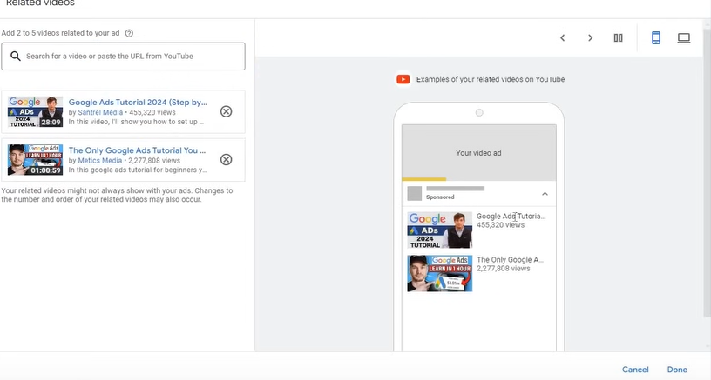

Now you can see above it will look like above

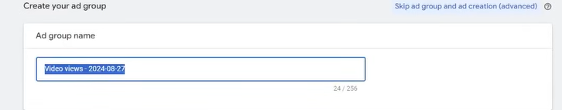

Ad group name should be proper

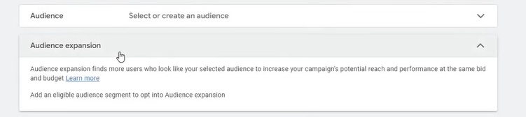

Now comes the audience

5:53:40

Here you select the audience that you want

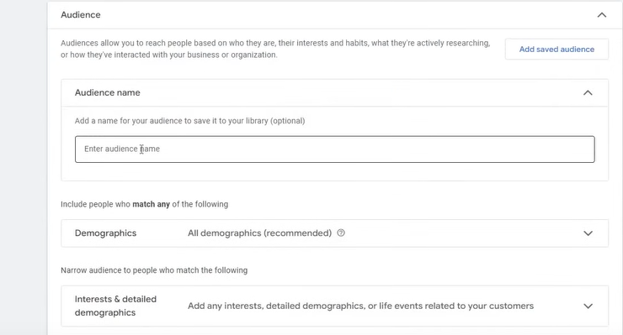

First you give audience name

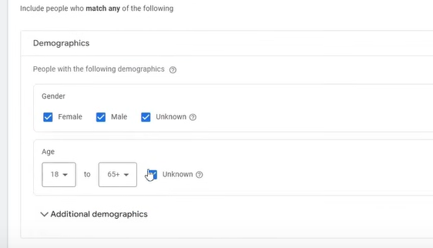

Now we tell the Demographics of the audience that we want to target

By unknown in gender we mean that the google don’t have any information about or they have not mentioned in their profile

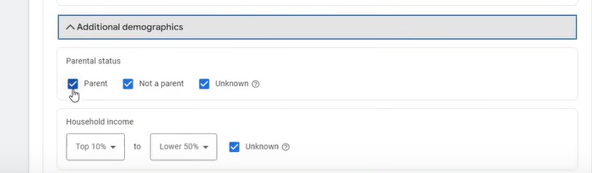

NOw comes the parental status Do you have parents or not

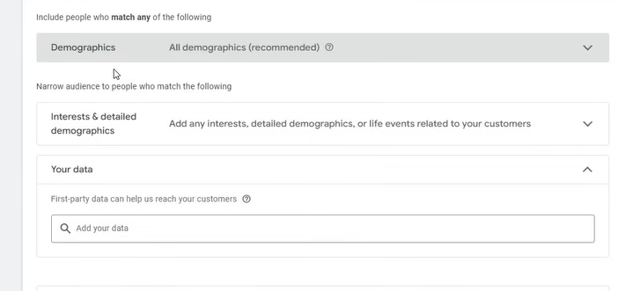

You can do it according to the targeting you are selling

What type of people views you want in that case you can use

NOw comes the interest and details demographics

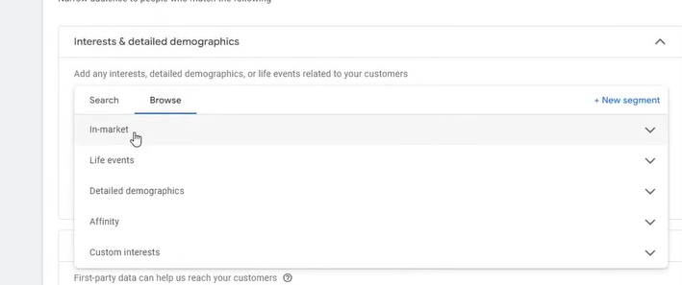

Here it gives different ways to target according to their interest

IN market are those audience which are ready to purchase and they are doing research to purchase

Affinity are those who have generatl interest in the product

IN detailed demographis it is advanced form of Demographics

IN life event syou can target according to the life events of a person

Choose according to your requirement

IN Browse tab they are grouped

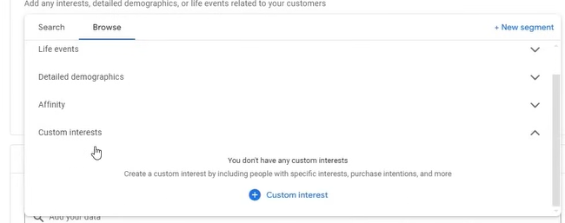

Now comes the custom interest

You can create your own interest group click on it

And a side window opens up

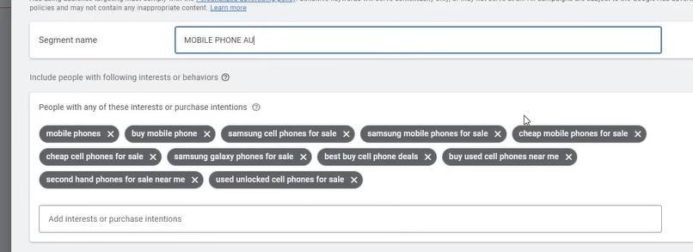

IN segement name you name this group

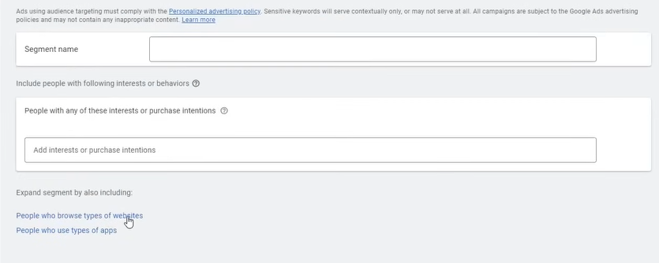

You can expand your targeted audience by targeting url and target the people who are hitting this end point so click on People who browse types of website

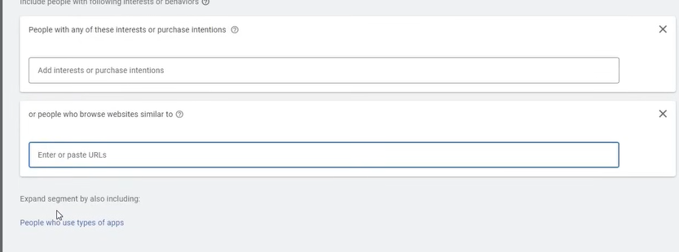

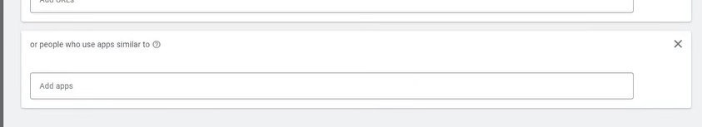

You can expand the targeted audience by the app they use

Such type of is available for us

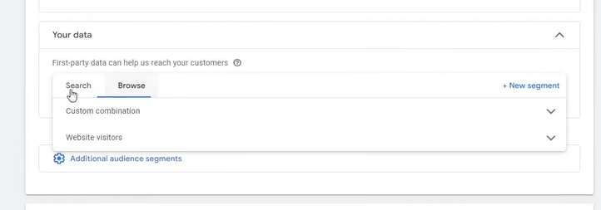

I think you can also include your own custom audience (or data of people)

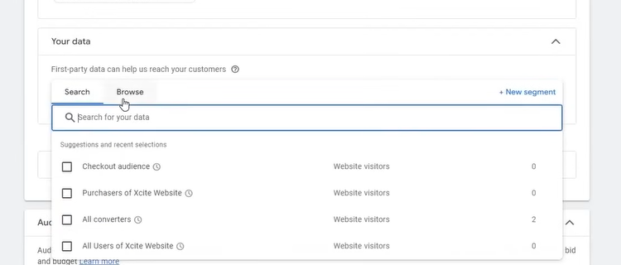like Checkout audience , all converters

Thhis data is collected by pixels maybe then google has a slight information that who are your customer that you want to target

Since it is a test account or demo website so it may face some errors

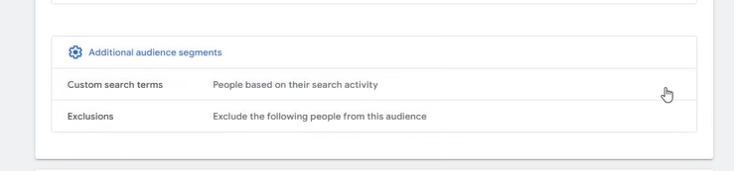

You can also add additional audience segment

Click on custom Search term edit button you will see when you hover over it

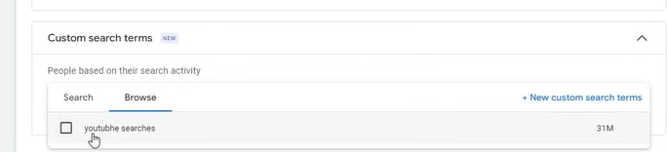

Maybe we are targeting according to the term searched

Click on new custom search term to make your own search term

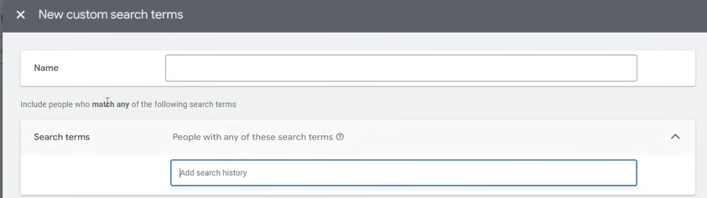

So now the above custom search term is for youtube

If someone is searching and in there seach history there are terms which we are targeting or

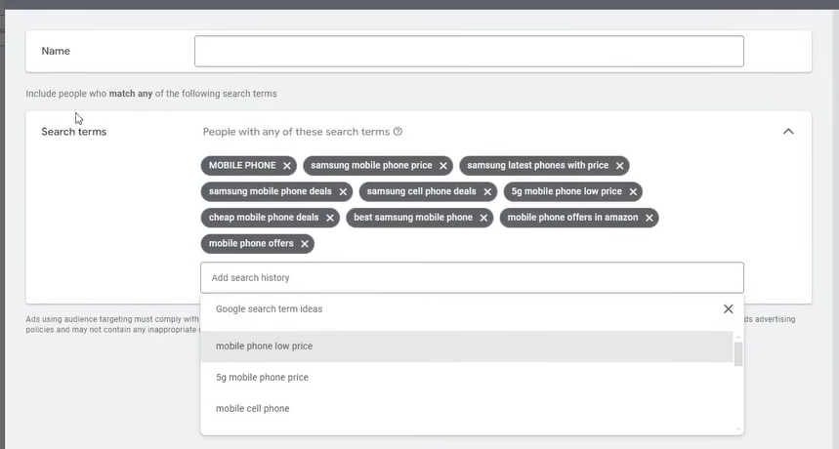

These things are being searched tehn ad will be shoen to them

It is a new option

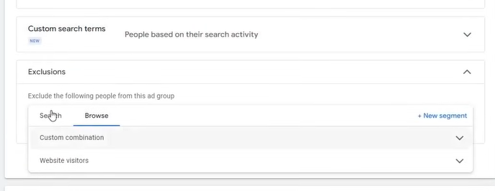

Now by exclusion we tell what type of audience we want to exclude form our targeting audience

It is not that necessary

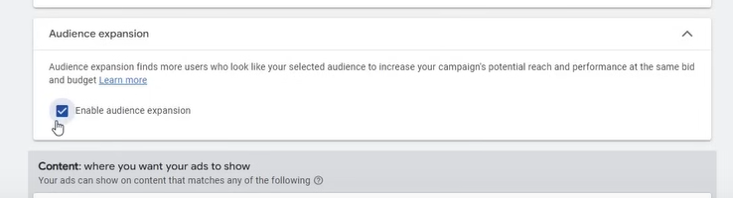

If you check the Enable audience expansion

Then the google will go beyond that audience that you have targeted means it will find the similar audience that we have targeted

It is a good option that you want to test

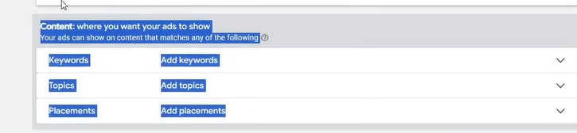

We will learn it when we will run display campaign

We are skipping it for now but in Display campaign we will understand that

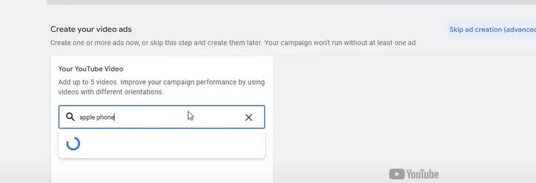

Now create your youtube ads by searching about the video and select it0020

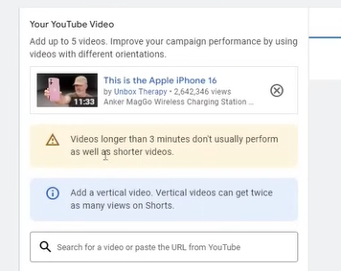

Now after selecting a long vieo it is giving us warning that

Video is longet the 3 minutes nad short video should be chosen bfor better performance

Now we need ot see what type of format we can run on it

Lets see ehat type of format it si allowing us

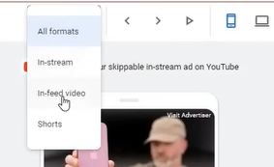

It is a video views campaign so it is allowing us three format that is in-stream ,in-feed video

And Shorts

You can add multiple videos here

You can add upto 5 videos here

NOw when it will be clicked where to take us we have to give the url

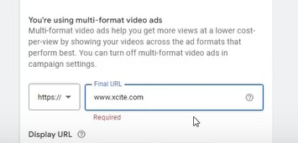

We are giving it a url

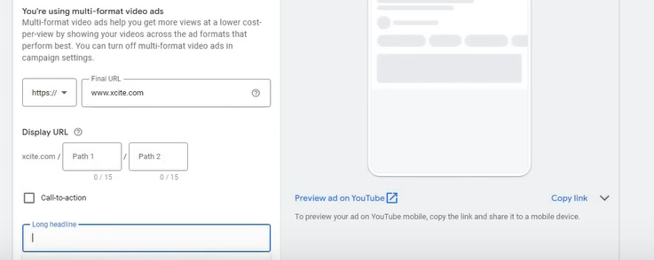

Now if you click on Preview your ad on yoututbe then yout ad will be shown

Now in marked below you can add the headlines for your Ad

**Phase 35**

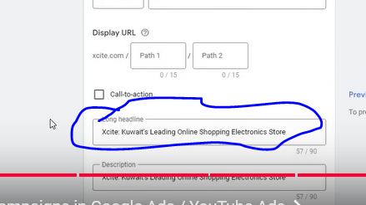

And then in below fierld you can add description x

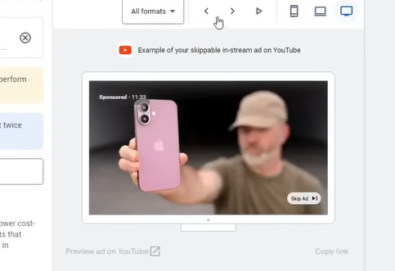

IN your preview you can see it in different view

That is in TV, desktop, etc

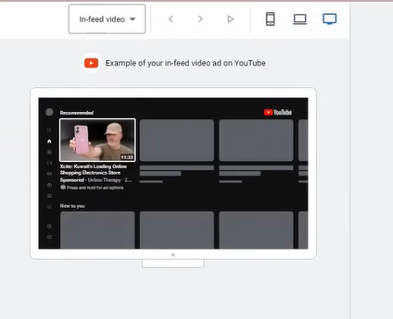

You can see it in-feed video preview

Now we have add-url option as shown below

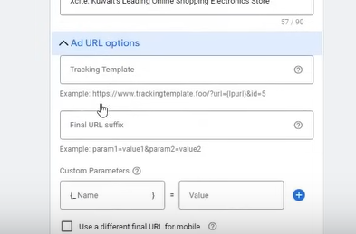

Skip it

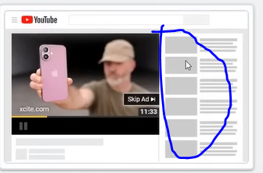

You must have seen it while playing video in youtube then in side menu as marked above

There will be a banner will be shown then that is companion banner

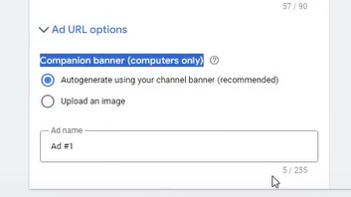

It can be auto generated and can be uploaded manually by choosing the second radio button

If you keep it autogenerated then this will be enough

Better will be that there should be one video in each ad group

If you keep multiple videos then your headline will be very general(who knows) then they may not be matched with some videos then this will not be good and misleading then such thing should not happen

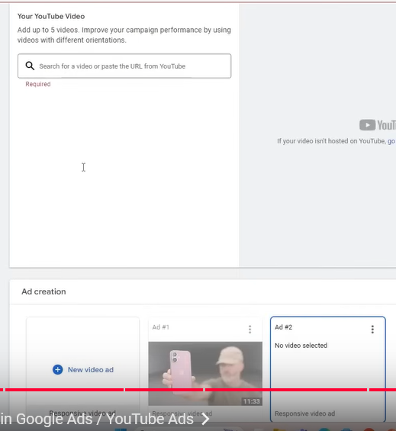

You can create video per ad

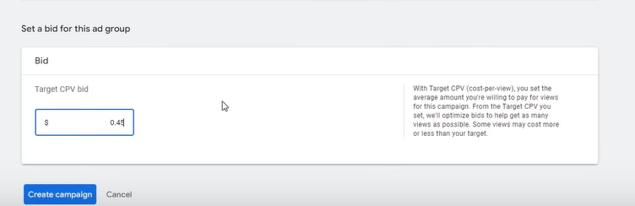

You can set target CPV (Cost per view ) (Maybe there is cost on impression in video ads)

Normally it is very cheap

Now we have understood this format now we will understand another format

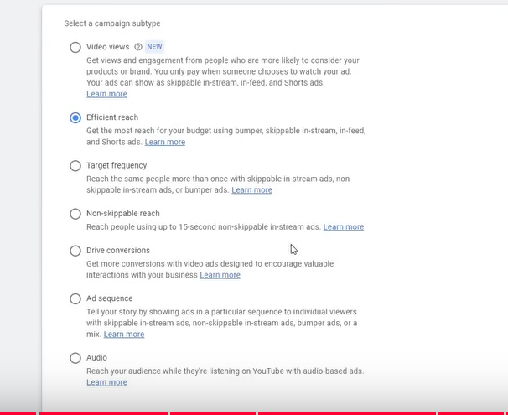

We will see Efficient Reach as shown above

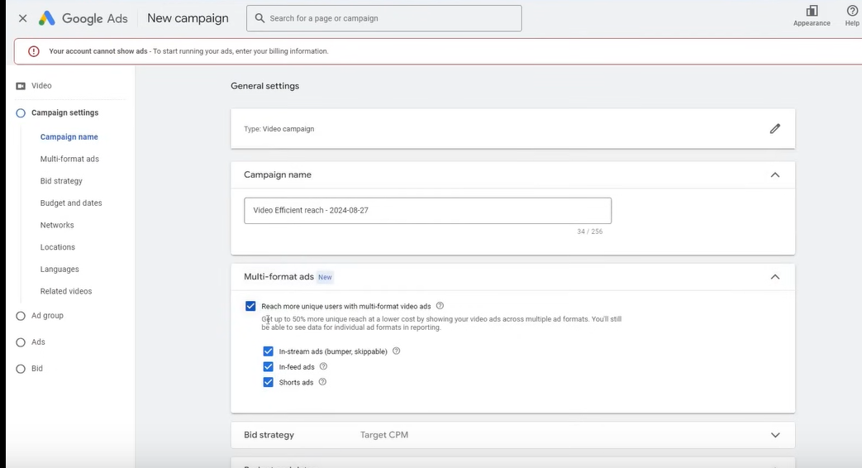

Now in campaign setting campaign name

WE set the campaign name and then what type of ad we want to run check that ad

By clickin on reach more unique users

You will use Multi-Format error

It is a new function that is a good thing because in video ads we don’t have optimization scope mainly automatic things run here and mostly thing good here

So we will test it then we will come to know that how much it is good

According to the teacher it should be tested

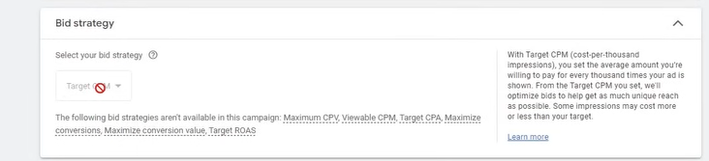

Now there is new bidding strategy that is Target CPM

CPM is the cost per 1000 impression

For every 1000 impression how much you want to pay is actually biding strategy

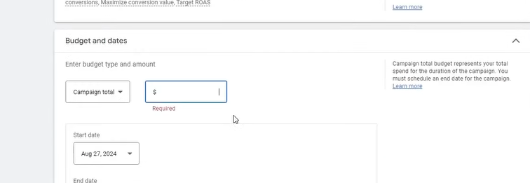

You can set Budget and dates for total campaign or other way

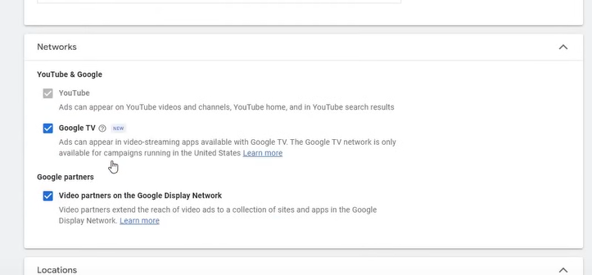

I think in network we tell what where ads will be shown whether in Google TV or other google partners

Then we have location or languages

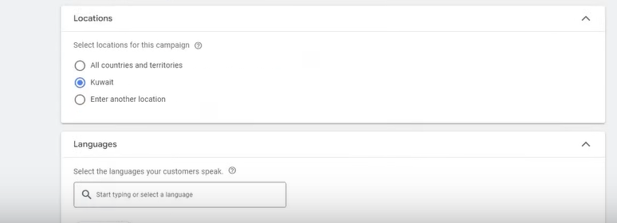

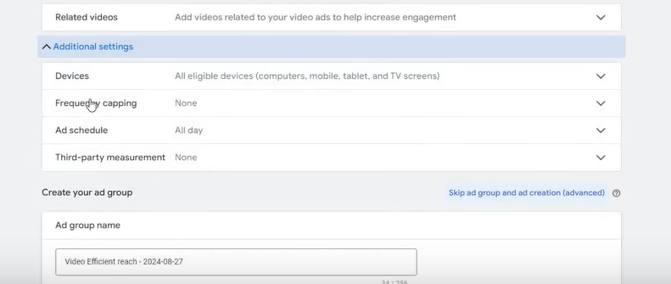

We have studied Related videos previously

Now all other Additional setting we have already studied

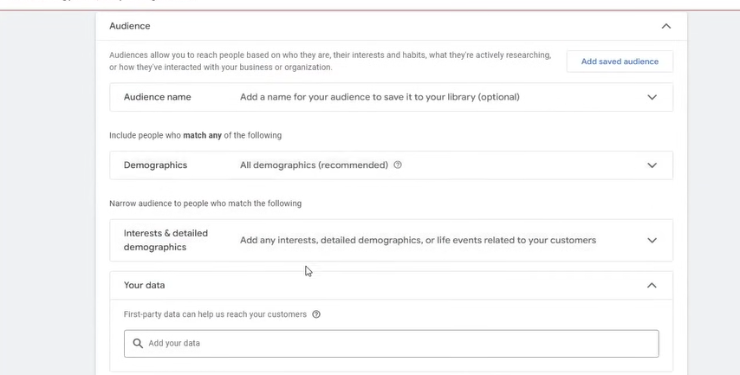

And then audience will be shown

WE have already studied it

We have seen audience expansion

Now we wll find video like we did in video views campaign

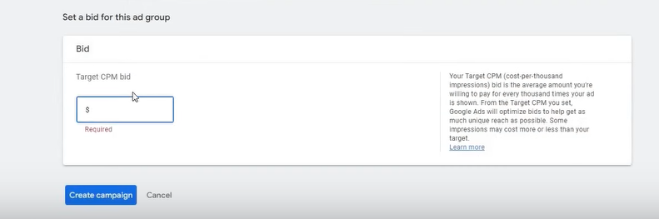

You set bid by target cpm

You can keep it 2 or 3 dollar If it is not performing properly then gradually increase it

For example we have set our CPM to 3 dollars but no impression or click are coming in our videos so I will slowly lowly increase like 3.5,4 ,5 until impression or click start coming means until we have not reached the idol point

It is all about

There are only three format there that is

1. In stream ads
2. In-feed ads
3. Shorts ads

6:05:00